***Preparation and Maintenance of ZOHO Books for***Keerthi Sweets

**Project Team members:**

**N.ANANDHA KUMAR,**

**K.ARASAKUMAR,**

**M.ARAVINTHAN,**

**J.AROCKIYA DASS,**

**S.VIJAYA KUMAR.**

**1. INTRODUCTION**

**1.1 Overview:**

This project is deal with Keerthi Sweets a Manufacturer and Trader of Sweets, relies on Zoho Books to manage their inventory, handle purchase orders, and generate invoices for their customers. They can track stock levels, manage supplier payments, and generate financial reports. Zoho Books helps them streamline their wholesale operations and optimize inventory management.

**1.2 Purpose:**

By maintenance of accounts in ZOHO Books, We have created the Items, Vendors creation, Preparation of Purchase Order, Purchase Invoice, Customer creation, Preparation of Sales order, Sales Invoice, creation of bank account, creation of new accounts, recording journal entries, recording expenses, recording bank receipts and payments and viewing of financial reports like Profit & Loss account, Balance sheet, GST Reports, Journal report, Account receivable summary report, Account payable summary report, etc.,

**2. Problem Definition & Design Thinking**

2.1 Empathy Map

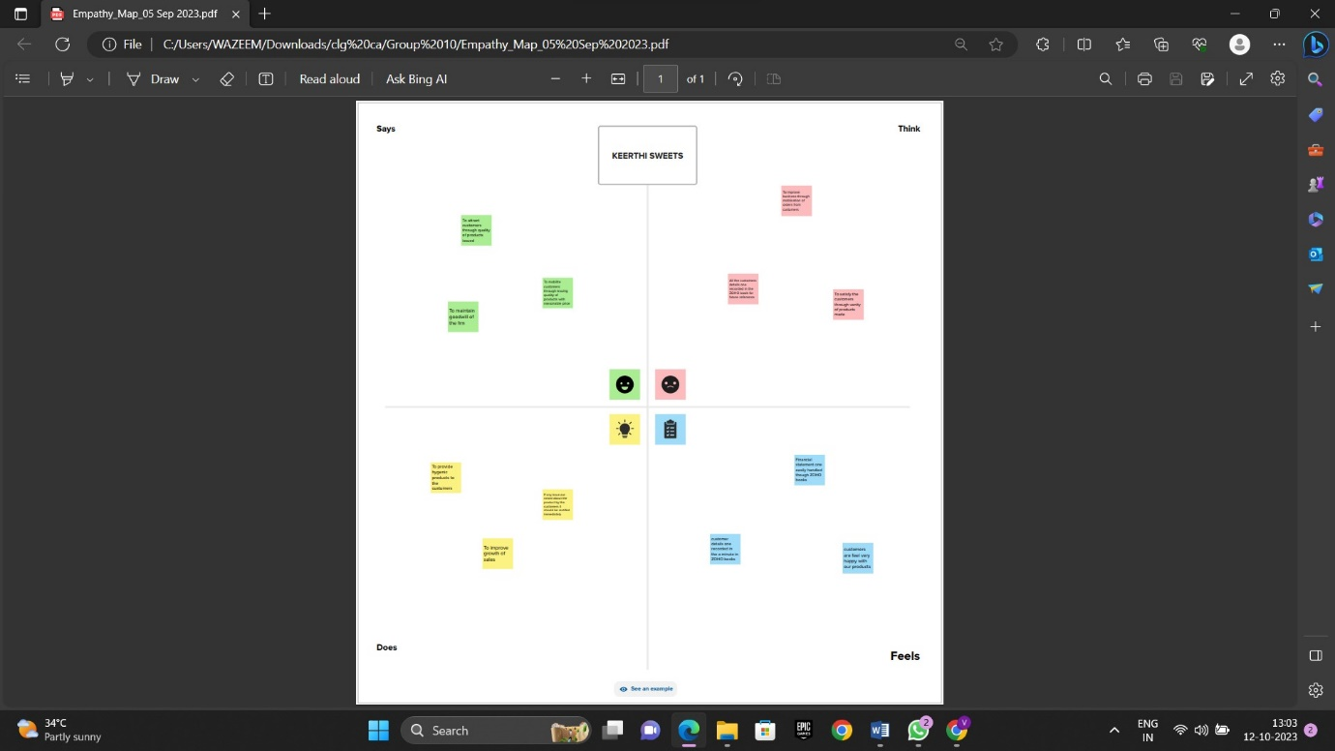

2.2 Ideation & Brainstorming Map

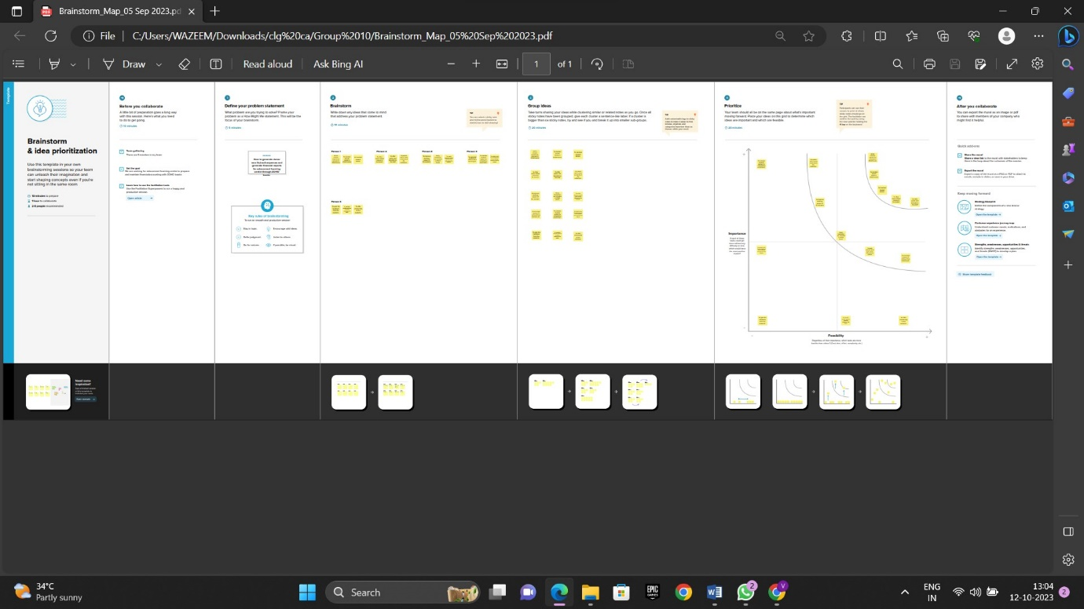

**3. RESULT:**

To Generate the Financial Reports:

1. Profit and Loss Account:

2. Balance Sheet

3. GST Reports

4. Journal Report

5. Accounts Receivable Summary

6. Accounts Payable Summary

**4. ADVANTAGES & DISADVANTAGES**

List of advantages:

* ZOHO books is cloud based software, so we access the software in any location.
* Creating of Organistion is very easy and user friendly.
* Appearance of software model is very easy to understanding.
* Creation of items, vendors, customers are user friendly while compare with software
* Preparation of purchase order and conversation to purchase Invoice made in a single step.
* Preparation of Sales order and conversation to Sale Invoice made in a single step.
* Default accounting step up is very useful and time saving.
* GST procedure is very easy to enter.
* Getting financial report and tax report in single step.

List of disadvantages:

* ZOHO books is cloud based software, which need internet and other technical facility.
* In absence of internet facility, the working in ZOHO books is very difficult.
* There is no secure in data of the organization

**5. APPLICATIONS:**

The ZOHO Books is good software in all type of organization and we get better results instantly. We collect the following data and entered in ZOHO Books in various modules like item creation, Vendor creation, customer creation, preparation of Purchase order, Purchase Invoice, sales order, sale Invoice, Making payment to vendors and Expenses, Received amount from Customers.

**Item creation:**

1. Kaju Barfi Rs.1000/- per kg

2. Gulab Jamun Rs.500/- per kg

3. Jangri Rs. 800/- per kg

4. Athirasam Rs.1200/- per kg

5. Mysore Pak Rs.1000/- per kg OUTPUT GST @5% is applicable on all the above products:

1. Sugar Rs. 50 per Kg

2. Flour Rs. 40 per Kg

3. Ghee and oil Rs.150 per Kg

4. Dry fruits Rs.600 per Kg

5. Flavourings and Spices Rs.500 per Kg

**Vendor creation:**

1. Iyyanger Sugar Traders (GST registered)

2. Raj Essence Suppliers (Non GST)

3. Quality Sweets Ingredients (GST registered)

4. Sweet Treats Raw Materials (GST registered)

5. Quality Delights Suppliers (Non GST)

**Customer creation:**

1. Suresh Kumar iyer is a GST registered person.

2. Priya Ranganathan is a GST registered person.

3. Aravindan Mani is not a registered person.

4. Kavitha Rajendran is not a registered person.

5. Karthik Krishnan is not a registered person.

**Preparation of Purchase order, Purchase Invoice:**

1. Iyyanger Sugar Traders – 200 Kgs Sugar Rs.50 pr kg for Credit Net 30 (GST registered)

2. Sweet Treats Raw Materials – 500 kgs Flour Rs. 40 per kg in Cash/Bank (GST registered)

3. Quality Delights Suppliers – 10kgs Dry Fruits Rs.600 kg in Cash/Bank (Non GST)

4. Raj Essence Suppliers – 5 kgs Flavourings and Spices Rs.500 per Kg in Cash (Non GST)

5. Quality Sweets Ingredients – 20kgs Ghee and Oil Rs.150 per kg in Cash (GST registered)

**Preparation of sales order, sale Invoice:**

1. 10/04/2023 Suresh Kumar iyer – 100 kgs of Kaju Barfi on credit – paid through bank on 25/04/2023

2. 20/04/2023 Priya Ranganathan – 50 kgs Jangri – Paid in cash on 20/04/2023

3. 20-04-2023 Aravindan Mani purchased 10kgs of Gulab Janum.

4. 20-04-2023 Kavitha Rajendran purchased 5kgs of Athirasam.

5. 15-04-2023 Karthik Krishnan purchased 20kgs of Mysore Pak

**Making payment to vendors and Expenses:**

1. Employee salaries Rs.5,000/- each for 10 employees Total Rs.50,000/
2. Office Rent Rs.20,000/- excluding GST @ 18% Total Invoice Value Rs.23,600/-.
3. Advertisement and Marketing expenses Rs.10,000/- paid in cash.
4. Miscellaneous Expenses Rs.5,000/- paid in cash
5. 10-04-2023 Paid to Iyyanger Sugar Traders 10500
6. 10-04-2023 Paid to Sweet Treats Raw Materials 21000
7. 10-04-2023 Paid to Quality Delights Suppliers 6000

**Received amount from Customers:**

1.25-04-2023 Amount received from customer Mr. Suresh Kumar iyer 105000

**6. CONCLUSION:**

In maintain of Keerthi Sweets accounts in Zoho books is very smart in all the aspects of entries. The basic accounting concept is enough for the operating person(Accountant/Data entry operator). This software is applicable for all types of organization. The entry models of software are easily understood and interest to work. Whatever reports we need, it’s already default in the report models. Totally it’s a good and very useful to the entire entrepreneur with low cost for operating financial department.

**7. FUTURE SCOPE:**

The idea for the founders of ZOHO Books is amazing and very clever. This is a great milestone in the field of accounts maintenance. They offer various plane as per the requirement of the proprietors. It’s a good gift to all the entrepreneurs.